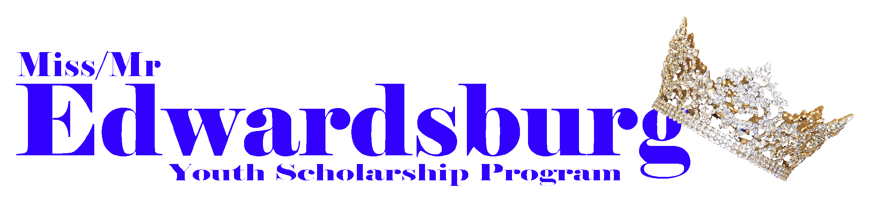

Blossomtime’s Theme: **Past, Present, and Future**

**The Edwardsburg Youth Scholarship Program Presents:**

**The Present Town of Edwardsburg**

Pageant Day: Contact Information:

December 4th, 2021 @ 3:00 PM missedwardsburg.com

Doors open at 2:30 PM eysp1957@gmail.com

Dinner begins at 5:30 PM

**Rehearsal Start Times**

**Miss/Mr andsTeens** 3:00 PM - 5:00 PM

**Jr. Teens and Prince/Princess**  3:00 pm - 4:30 pm

**Dress Rehearsals at the PAC** 5:00pm-9pm

**Pageant Day Check-in:** 11:00 am

Please arrive promptly at the Legion and ready to go 15 minutes prior to start time. Once you are checked in, parents shall leave and return 10 minutes before the end of practice for a short wrap up meeting. **Remember rehearsals are closed to parents.**

**October 31st - Meet for Registration**

* **Enrollment Forms**
  + Application
  + Proof of Residency
  + Proof of GPA **(Miss and Mr. Only)**
  + Medical Release
  + Photo Release
  + Certificate of Understanding

**November 7th - First Rehearsal and Workshop**

* Sign Ups **(Last Day)**
* **Enrollment Forms are DUE**
  + Application
  + Proof of Residency
  + Proof of GPA **(Miss and Mr. Only)**
  + Entry Fee ($50.00) Discount if you Like/Follow our page on Facebook and Instagram
  + Medical Release
  + Photo Release
  + Certificate of Understanding
* **Rough Draft of Bios DUE**
* **T-Shirt Money Due**
* Assign Contestant Numbers
* Interview workshop with Tammy Boyer (Miss and Miss Teen contestants only)
  + Bio training, interview training and physical and non-verbal training included
* Interview training for Jr Teen/Princess and walks
* Mary Kay Cosmetics (Miss and Miss Teen contestants only) Make-up Seminar

**November 14th - Second Rehearsal**

* **Final Copies of Bios are DUE**
* **Good Luck Ads are DUE**
* Schedule Dress Approvals

**November 21st - Third Rehearsal/ Dress Approval**

* **Ticket Money DUE**
* **All Fundraisers DUE**
* You will bring everything you will wear Pageant Day
  + Pageant Attire
  + Interview Attire
  + Pageant Shoes
  + Interview Shoes
  + Jewelry for Pageant Attire and Interview Attire

**November 30th - Dress Rehearsal @ PAC**

* 5:00pm - 8:30pm
* Going Over Coronation
* Onstage Questions

**December 3rd - Dress Rehearsal @ PAC**

* 5:00pm - 8:30pm

**December 4th**

PAGEANT DAY!

**What to Wear to Practice and What to Bring:**Please wear casual dress attire. Nothing too tight. Bring your pageant shoes to practice in. The Princess, and Junior Teen girls are encouraged to just wear shoes that are comfortable to them. The Teen and Miss Contestants need to wear shoes that fit their comfort level but no more than 4” heels. Please bring a water bottle to practice. And of course we want you to bring your smile and your awesome attitude.  
**Ticket Sales:**  
Each contestant needs to sell 10 VIP tickets and 10 General tickets. Tickets are seated on a first come first serve basis. There is not a bad seat in the PAC. The pageant committee will have reserved seating for judges and tellers.  
**GLA:**  
Each contestant needs to sell at least 15 Good Luck Ads or $250.00 worth.  
**Entrepreneur:**  
An Entrepreneur will be selected pageant wide. To be considered for Entrepreneur the contestant must raise at least $500.00. This total is a combined total of ticket sales, GLA, Sponsorships, Martin’s Books, and Airbeads. Anyone that raises $800.00 or more will be announced on stage, pageant day.The winner of Entrepreneur will receive an Event Ticket Package to approved Blossomtime/Community Events.   
**Fundraising:**  
This year Contestants will be selling Martin’s Coupon Books, Airbeads, GLAs (15 total GLA or $250.00 worth), and Sponsorships. These Fundraisers will help raise money for crowns, banners, pageant day expenses, prizes, scholarships, and for our float.   
**T-shirts:**  
Pageant T-shirts are required for all contestants. These will be worn for the opening number dance and Interviews for the Prince, Princess, and Junior Teen Contestants.  
**Interviews:**  
Interviews will be held the day of the pageant. The Miss, Mr., and Teen contestants will have individual interviews with a panel of three judges and contestants will be given a group interview also.  
Junior Teen and Prince/Princess divisions will have individual interviews with a panel of three judges but will be interviewed by the judges one-on-one. Less scary for them to sit with one person instead of three people.

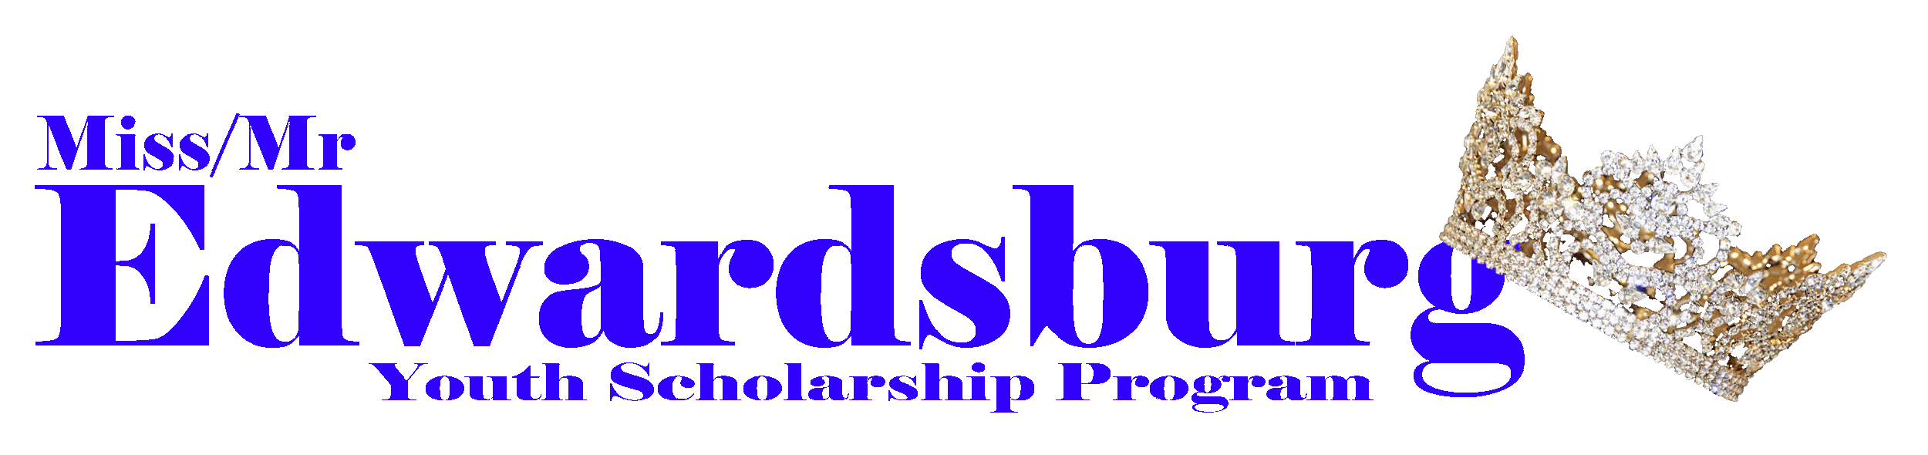

Mandatory Events

**Blossomtime Fashion Show -** All Miss and Mr. court, all Miss and Mr. Teen court, and all title holders

**Mr. Blossomtime Pageant & Showcase of Queens -** All court members

**Miss Blossomtime Pageant -** All Miss and Mr. court, all Miss and Mr. Teen court, and all title holders

**Coronation Ball -** All title holders

**Grand Floral Parade -** All court members